Cornerstone House
URN 2861301

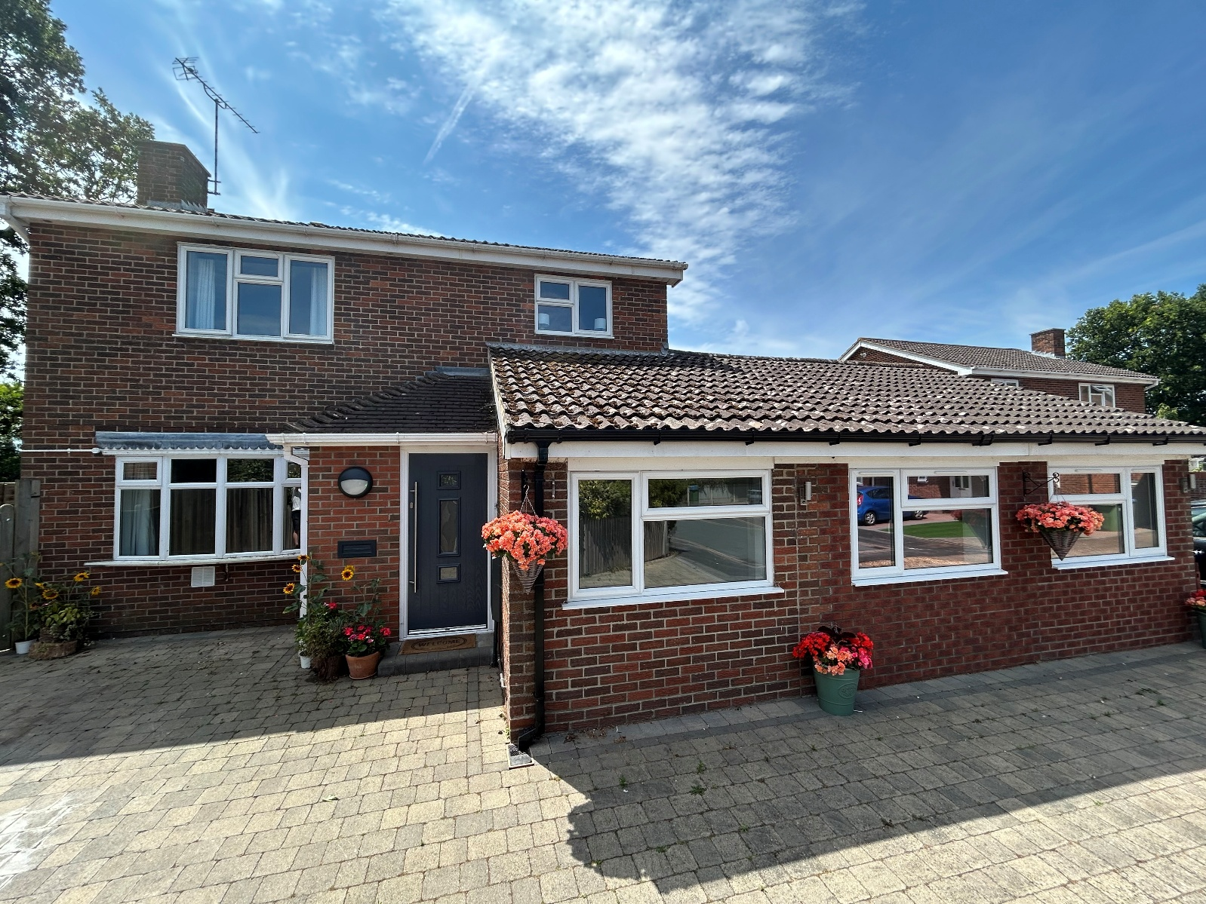
Statement of Purpose

June 2025

Reviewed 17th February 2026

Contents
Quality and Purpose of Care 2
Cultural, linguistic, and religious needs of children and young people 4
Complaints Procedure 4
Access to Policies 5
Views, Wishes and Feelings 5
How children and young people have their say 5
Child/ Young Person’s Guide 6
Reviews 6
Feedback 6
Rights of Children/ Young People & Anti-discriminatory Practice 6
Education 7
Enjoyment and Achievement 7
Health 8
Informed therapeutic approach 8
Physical Health 11
Emotional and Mental Health 11
Positive Relationships 12
Arrangements for spending time with Family and Significant Others 12
Protection of Children 12
Safeguarding Children & Young People 12
Whistleblowing 13
Working in Partnership 13
Monitoring & Surveillance 14
Emotional and Behavioural Response 14
Physical Intervention 14
Rewards and Consequences/Reparations 15
Procedure for Unauthorised Absence/ Missing from Care 16
Leadership and Management 17
Management and Staffing Structure 17
Supervision of staff 18
On-Call System 18
Agency Care Staff 18
Training 18
Monitoring 19
Care Planning 20
Referral Process 20
Emergency Referrals 20
Care Plans 21
Preparing Young People for Leaving Care 21
Further Information 22
Contact Details ………………………………………………………………………………………… 20

Quality and Purpose of Care

The home and the children/ young people we care for

Cornerstone House can accommodate up to four young people of any gender, aged between 8 and 17 years old (on admission), who experience emotional and/or behavioural difficulties. We recognise that this may mean they have additional needs which require supporting alongside their emotional and/or behavioural difficulties including but not inclusive of learning needs, ASD, ADHD, global developmental delay, diabetes. Further training and/or guidance will be sought where necessary.

Cornerstone House is a spacious and beautifully presented property in a quiet residential area of Fareham, Hampshire. The house is not distinguishable from other houses in the area. At the front of the house there is a driveway suitable for parking a minimum of four vehicles. On the ground floor the home has an open plan kitchen, garden room, dining area, and lounge. There is also two young people’s bedrooms, a shower room, and a games room. The first floor has a family sized bathroom, two more young people’s bedrooms, and an ensuite staff office/sleep-in room.
There is a picturesque garden to the back of the property which has some outstanding features. Our young people have access to a semi-enclosed seated area where they able to relax and enjoy BBQs in, a multi-purpose room and plenty of space to safely store their outdoor equipment.
The home is not suitable for people who require the use of a wheelchair and there are no specific adaptations to the house to accommodate any specific requirements. This would not preclude admission as each referral is considered on their own merits and suitability for the placement.

Cornerstone House is located in a village called Stubbington just outside of a town called Fareham, Hampshire. There are lots of nearby parks and outdoor space and we are centrally located between the city’s of Southampton and Portsmouth, we are just a few minutes away from the beach and a short drive to the forest and the Southdowns. There is a whole host of attractions nearby for exciting days out. Examples include ice skating, roller skating, indoor karting, bowling, escape rooms, laser quest, the cinema, and indoor trampolining.





Fareham train station is just 2.6 miles away from the home and the X4 and X5 Solent Ranger busses leave daily from a nearby street to prominent towns/cities, including Portsmouth. The road links to and from the house are also excellent. The local area has provision for children and young people to practice the faith of their choosing. We have ample access to health services and hospitals. School and college provisions in the local area are as needed to meet the needs of the children/ young people placed in the home.

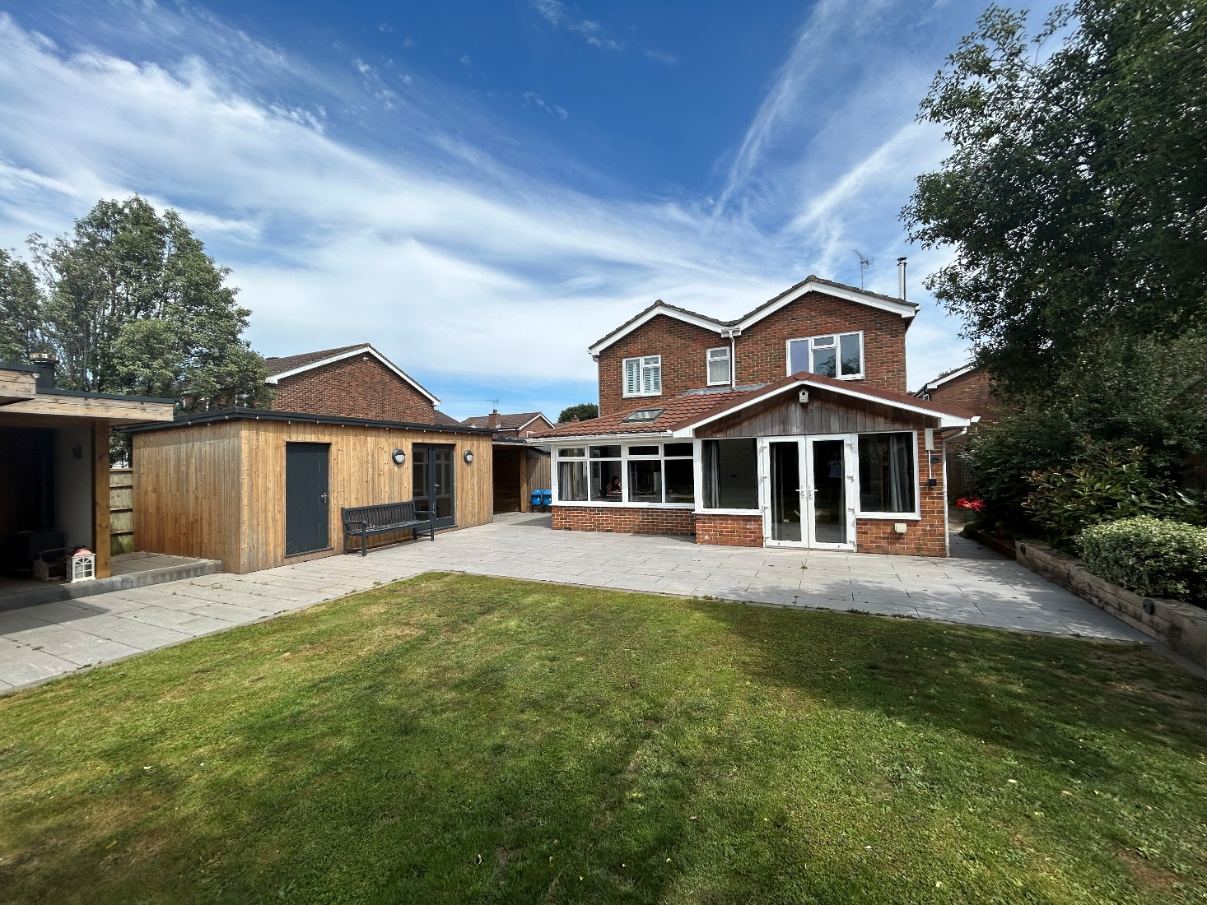

Our aims, ethos, and approaches

We aim to create a safe and nurturing attachment focused and trauma informed environment; enabling children and young people to recover from past trauma and grow to achieve their full potential. We provide an outstanding quality of care for children/ young people, who, for whatever reason, are unable to live with their own families.

We aim to provide the highest quality of care which allows children and young people to feel safe and valued. We will support children and young people to learn about themselves and to develop their sense of self, whilst also supporting them to identify goals and prepare them for their future. Our objective is to develop the physical, emotional, and psychological well-being of the children and young people in our care.

Cultural, linguistic, and religious needs of children and young people

When our staff are looking after a child/ young person of a different culture and ethnicity to themselves, they have a responsibility to help the child/ young person define themselves with increased knowledge of their culture and ethnicity, at the same time as bringing them into the new culture that is already present in the home. Without connection the child/ young person can feel ‘lost’ or searching for their own individual identity. Increased awareness of positive self-identity and confidence is essential in a child/ young person making secure attachments. The cultural and ethnicity needs of the child/ young person will be explored and assessed at the referral stage and as they settle into the home; and training/ resources will be sourced as required.

For those children that come into our home who have additional communication needs or whose second language is English, the home will find suitable ways in which they can offer support with this i.e. widget, writing things down, google translate. Whilst we will endeavour to support those where English isn’t their first language and encourage a diverse staff team, we recognise that this may not be possible and would utilise our other tools as previously described.

It is important for a child/ young person’s physical, intellectual, and emotional wellbeing that consideration is given to their religious background and needs. This may mean supporting them with the foods they wish to eat and religious rituals they want to observe, but also helping to ensure that child remains connected or to renew their connection with the religious community they have grown in. Prior to placement, our staff will find out as much as they can from family members, Social Workers, and the faith community the child/ young person is from, and the child/ young person themselves. We will support every child/ young person to maintain their faith and values in line with their wishes.

We will support the young people within the home to understand others ethnic and cultural wishes and needs through education and promoting mutual respect.

Complaints Procedure

Children/ young people will be informed about the home’s Complaints Procedure in a way that is appropriate to their age and level of understanding. This information is detailed in the Child/ Young Person’s Guide, which is given to them before or upon admission to the home. Such information includes an explanation of the role of an advocate and provides contact details for independent advocacy services who can help children make complaints or make a complaint on their behalf. The Registered Manager will take all reasonable steps to ensure that children/ young people feel comfortable raising complaints, that they are supported to make complaints and are free from reprisals if they choose to do so. Children/ young people will be given any reasonable assistance they require or request, including being advised that they may ask someone else to make the complaint on their behalf.

Parents, guardians, and external professionals will be made aware upon admission that they can complain verbally, in writing, or email either to Cornerstone House or the Placing Authority.

Access to Policies

The following policies are available on the company website at https://www.fourcorners.org.uk/policies/

- Complaints Policy
- Safeguarding and Child Protection Policy
- GDPR

All other policy documents referred to in this Statement of Purpose are available on request, with a justification of need by contacting either the Registered Manager or the Responsible Individual.

Views, Wishes and Feelings

How children and young people have their say

Cornerstone House believes that the needs of the individual are paramount. We enable each child/ young person to express their wishes and feelings and we aim to listen to their ideas and preferences and consider their emotional and behavioural needs.

Cornerstone House values the importance of being able to establish open and honest communication with young people about all issues that will affect them. This will convey the message that they are important, that they are cared for, and their wishes and views are respected. Such an atmosphere promotes positive self-esteem which is crucial to the development of a sense of self.

We will have weekly children/young people’s community meetings where the children/ young person is able to voice their thoughts and feelings on matters inside and outside the home e.g., birthdays, activities, food in the home, what they would like for the home etc.

Key work sessions will also be held, conducted more informally and as the child/young person wishes, whereby they will be able to talk about their experience of the home and to reflect upon what is going on for them. They will also be used to discuss any areas of concern or support which may have arisen previously.

The manager will meet regularly with the children/ young people. This may be an informal catch up; or could follow a more formal agenda depending on the child/ young person’s needs. There is an open-door policy and culture within the home for children to talk about their feelings, ideas and wishes at any time.

Child/ Young Person’s Guide

All children/ young people will be given a Child/ Young Person’s Guide prior to or on admission, which includes information on the home, the staff, the complaints procedure, important telephone numbers and addresses, and a list some of the routines and expectations at Cornerstone House.

We are committed to working flexibly and imaginatively with all children/ young people, professionals, and families to ensure that the best interests of every child/ young person in our care are consistently served.

Reviews

After the Initial Planning Meeting, which should take place prior to admission, a Placement Planning Meeting will take place within 5 days of the child/ young person moving to Cornerstone House. An initial Looked After Child (LAC) review must take place within 28 days of placement, and a second review convened within 3 months; followed by statutory reviews at least every 6 months. Where the referral process has been expedited, a meeting regarding the placement will take place within 24 hours.

It is our policy that children/ young people, parents/ guardians, and Placing Authorities should take
a full and meaningful part in any decision-making process. The review process will be discussed with the child/ young person, and they will be encouraged to take an active role to share their wishes and feelings prior to and within the review meetings.

Whilst the responsibility for the reviews is primarily with the social worker, the manager will ensure that they follow up for these dates and offer to facilitate all the meetings in the home.

Feedback

In the interests of improving our service, staff will record any complaints, comments or compliments from children, parents/ guardians, Social Workers, or any other external agencies. These will be kept on Clearcare and will be used to inform our practice and procedures. Feedback will also be sought as part of the 6-monthly quality of care review (Regulation 45).

Rights of Children/ Young People & Anti-discriminatory Practice

Cornerstone House believes in promoting equality, valuing diversity, and working inclusively. This is the world we want for our children and young people, and it is at the heart of everything we do. We work within the spirit and the practice of the Equality Act 2010 by promoting a culture of respect and dignity, and pro-actively tackling and eliminating all forms of discrimination. Every effort is made to ensure that Cornerstone House is welcoming to all children and young people and others significant to their care and well-being.

Children/ young people are cared for by staff who have been suitably trained in all aspects of equality and diversity including legislation and their responsibilities. Staff are expected to examine ways in which diversity can be valued and activities adapted to meet the individual child/ young person's needs including but not exclusive to disability, special educational needs, gender identity, sexual identity, cultural and religious identity. Staff are also expected to offer appropriate support to aid
inclusion and ensure that the children and young people can fully participate in Cornerstone House’s activities.

Staff are expected to challenge attitudes, behaviour and language that are non-inclusive and discriminatory, in a positive way. The Registered Manager is also expected to monitor the range of children and young people placed within the home to ensure the home is reaching all and not creating barriers to certain groups.

All children and young people will be made aware of our Prevention of Bullying Policy as part of their introduction, helping to provide positive guidelines on how to respect and treat others. Bullying is not tolerated in any form or against any person living or working in the home or visiting. Bullying is prevented and addressed through effective matching at the time that young people are referred to ensure that any risks of bullying arising within the group are safely managed.

Cornerstone House encourages children/ young people to speak for themselves about issues that are important to them, in the most appropriate way for them. All young people will be offered access to advocacy services and made aware of other external independent organisations such as the Children’s Commissioner (please also refer to the Child/ Young Person’s Guide). As identified in their Placement Plan, they may also have an independent visitor. Children/ young people will be supported to understand that these people are available to look after their rights and can advocate and speak up for them when and if needed.

Education

Whilst Cornerstone House does not provide formal education (not dual registered as a school), we understand the importance of getting children/ young people into education and supporting them to remain engaged.

A plan for the child/ young person to be in school or alternative education must be agreed at a child/ young person’s Placement Planning Meeting, and we will support the child/ young person’s attendance and achievement with this. Support includes transport to and from school, help with homework, and computer access with appropriate supervision as required. Staff will support the young person by monitoring their personal educational plans and attending all relevant meetings. Notes will be kept in the child/ young person’s Clearcare file, and key workers will ensure that they have details of any Special Education Needs statements.

If an education provision is yet to be identified, or as an additional provision, staff can engage the child/ young person in educational-based activities. Cornerstone House can access and deliver an AQA unit award scheme to allow the child/ young person to gain certificates covering subjects related to hobbies, interests, and life skills. This will only ever be used as an interim measure if agreed within a young person’s Care Plan, to engage the child/ young person while the home works with the Local Authority to identify a suitable school provision. Fees for this service are additional to placement fees.

Enjoyment and Achievement

The importance of providing leisure time and activities to the children/ young people who live with us is at the forefront of our care. A wide variety of interests can be explored, individual or group activities, and there are many forums created for children/ young people to discuss what activities they would like to participate in.

Children/ young people will be encouraged to participate in age-appropriate activities outside of the home. These will be supported initially; however unsupported activities can be considered after individual Risk Assessments. Staff should be aware of where children/ young people are at all times, and clear time boundaries for return will be given. Cornerstone House will endeavour to have an activity arranged more often than not, we recognise that some children and young people can find it overwhelming being out all the time and appreciate times they are able to engage in in-house activities and relaxing. Some of these may be arranged with external agencies with the aim to encourage children/ young people to socialise with their peers outside the home. Activities that may be arranged with Cornerstone House include creative or play activities at home, theatre trips, shopping, watching football matches, visiting theme parks, going to museums and places of individual interest, dance lessons, drama, football, and community work.

Cornerstone House will offer in-house activities such as cooking, going for a walk, playing board games, art and craft sessions, life skills work. Activities will be utilised as a medium to build relationships between staff and the children/ young people, and will often occur on a one-to-one basis, centred on the individual’s interests or building life skills. This time provides an opportunity for staff to meaningfully engage with the child/ young person and offers a space for play, growth, and communication.

All activities are organised with reference being made to each child/ young person’s Placement Plan and Risk Assessment.

Health

Informed therapeutic approach

We aim to provide the young people a home that can help them in the process of recovery from developmental trauma. Recognising that the healing process depends on the quality and strength of our relationships with the young people we care for. Our model of therapeutic practice is informed by attachment-based theory and its specific practical implementation tool the form of PACE as a guide for the way we interact and relate to the young people. We draw from the work of Dan Hughes’ and Kim Goulding’s models of trauma-informed care.
PACE is a therapeutic approach and guide for every day to day interaction with others that can be a powerful tool the staff to build strong connections with the young people in our care. It emphasizes four key qualities:
• Playfulness: This involves using a light hearted and engaging tone during interactions. It's about creating a fun atmosphere that helps young people feel comfortable expressing themselves freely. • Acceptance: This means unconditionally accepting a young person's feelings and thoughts, even the negative ones. It's about communicating that we understand and value their emotional experience.
• Curiosity: This involves going beyond simply reacting to a young person's behaviour and instead trying to understand the underlying reasons behind it. We can achieve this by asking open-ended questions and seeking their perspective.
• Empathy: This means showing young people that we truly understand and care about their feelings. It's about validating their emotions and offering support.

By incorporating these qualities, PACE helps young people feel safe and secure in their relationship with us, the staff. This sense of safety allows them to better regulate their emotions, develop a positive self-image, and build strong social and emotional skills. Ultimately, PACE fosters trust and connection between us and the young people, leading to more effective communication and cooperation.

There is a common misconception that being a therapeutic placement means that young people will receive structured therapy from a professional with accredited qualifications. This kind of therapy is likely to be a very small amount of time within the overall support that is needed for the young people. The House Model of Parenting is what we have chosen at Cornerstone House as our guide and therapeutic model for the staff on how enhance their skills a therapeutic practitioner.

‘All children thrive when they experience emotional connection alongside behavioural support. Developmentally traumatised children can only begin to recover when they experience this. The house model of parenting is built around this basic principle’ Hughes, Golding & Hudson (2019).

The House Model of Parenting offers a valuable framework for us to create a secure and nurturing environment for the young people in our care. Just like a house, a strong foundation is essential. This foundation represents a sense of safety and security, both physically and emotionally.

Our role is to build this foundation through:
• Consistency and Predictability: Establishing clear routines and expectations provides a sense of stability and fosters a feeling of "knowing what to expect."
• Attunement and Responsiveness: We strive to be attuned to each young person's unique needs and emotions. Actively listening, validating their feelings, and offering support builds trust and connection.

With this secure base in place, we can focus on the other key aspects of the model:
• Building Relationships with PACE: By incorporating PACE into our interactions, we can build strong, positive relationships with the young people. These relationships are the cornerstone of effective communication and behaviour management.
• Structure and Supervision: Providing clear and consistent boundaries alongside appropriate supervision allows young people to explore their independence within a safe framework.
• Creating a Positive Atmosphere: We nurture a positive and supportive environment by establishing positive routines, celebrating achievements, and creating meaningful family rituals. This fosters a sense of belonging and well-being.
• Self-Care for Staff: Recognizing the importance of our own well-being, we prioritize self-care practices to ensure we can be the best possible caregivers for the young people entrusted to us. By incorporating the House Model's principles, we can create a safe haven where young people can feel understood, supported, and empowered to reach their full potential.

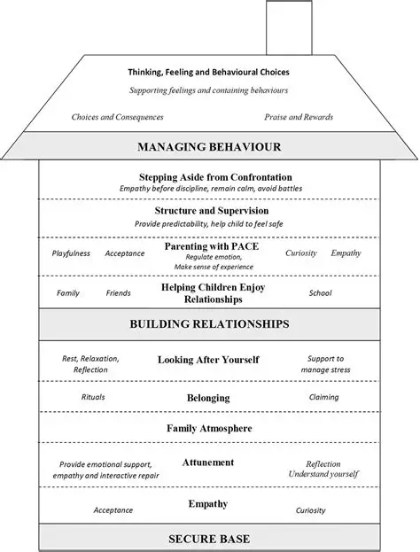

Figure 1. The House Model of Parenting, Healing Relational Trauma with Attachment–Focused Interventions – Dyadic Developmental Psychotherapy with Children and Families. Hughes, Golding & Hudson, 2019.

Details of the team’s qualifications and arrangements for supervision can be found in Appendix A.

Physical Health

The health of our children/ young people is extremely important. Each child/ young person will be registered with their own GP, dentist, optician; and if needed another specialist at the earliest opportunity. Where possible the home will use the same provisions for each young person to build a relationship with providers in the interests of our young people.

Each young person’s needs are different, and this is considered when deciding their care plan. Factors may include general health and cultural differences. All our records will be well maintained, and all contact made with the above health organisations logged and detailed.

Any medication taken by the child/ young person will be recorded accurately. Our records include the medical history of the child/ young person to include immunisations, allergies, and previous operations. Some young people may self-medicate and we will ensure that a self-administration is completed with them prior to increasing their responsibilities.

Each child/ young person, if a Looked After Child, has an annual review health assessment; this is completed by a looked after children’s nurse or a Doctor.

Team members are first aid trained and this is renewed three yearly. All will be competent to deal with emergencies and will be trained in conditions which may require specialist medication.

Each child/ young person will be encouraged to undertake regular exercise, this could be through going for walks, visits to the gym, jogs round the local park, participating in fitness videos, or joining an activity they are keen on for example playing football.

A great importance is placed on the personal hygiene of our children/ young people. They will be encouraged to take care of themselves and to take pride in their appearance.

Staff will promote healthy eating, utilising the ‘Good food plate’ and any particular professional health guidance for the individual. Healthy snacks will be available during the day and children and young people will be encouraged to contribute to their weekly menu’s.

Staff will promote healthy living through positive role modelling which will benefit the children/ young people and help them to live in an environment that promotes health and well-being within the wider community.

The home has a non-smoking policy. Any child/ young person moving to the home who smokes will be supported with a smoking cessation programme via the GP.

Emotional and Mental Health

The home will build good working partnerships with the local Child and Adolescent Mental Health Service (CAMHS) and those from neighbouring Local Authorities. The staff team will be made aware of CAMHS referrals and of treatment options offered by CAMHS.

We can work with external bodies to identify and support professional therapeutic intervention for each child/ young person. Formal and structured therapy including cognitive behavioural therapies, play therapy, crisis intervention, and specific behavioural work can be accessed through appropriate referrals to relevant professionals. We will work with a consultant psychiatrist to aid with training, therapeutic care planning, and supporting the staff team via group supervision and reflective practice.

Positive Relationships

Arrangements for spending time with Family and Significant Others

Arrangements to spend time with family and friends will be established at the Placement Planning Meeting and subsequent reviews to establish plans and any risks/ restrictions that may be considered necessary in the best interests of the child/ young person. Arrangements for support, supervision, and/ or a separate venue for this time will be arranged as per individual need. We are aware of the importance of maintaining and promoting relationships between a child/ young person and their family and recognise that there may be family work required to repair or build on foundations that exist. The team will be provided with training by the Manager in relation to supporting contact and family relationships.

Children/ young people’s relationships with their parents/ significant others will be supported and
important people will be kept informed of the child/ young person’s progress where appropriate. The child/ young person will be regularly consulted regarding their wishes and feelings about spending time with family/ significant others. All decisions made will be in consultation with the child/ young person and with input from relevant family/ significant others and professionals.

Protection of Children

Safeguarding Children & Young People

All children and young people have an absolute right to protection. Cornerstone House will have a Designated Safeguarding Lead who is responsible for dealing with any concerns about the protection of children/ young people and ensuring that appropriate arrangements for keeping children and young people safe are in place.

Cornerstone House’s DSL is:

Registered Manager: Ben Hancock
Contact Number: 01329 745 715, 07767 920593
Email Address: ben@fourcorners.org.uk
Business Address: 25 Ennerdale Road, Fareham, PO14 2DS.

In the DSL’s absence, or where a safeguarding allegation concerns the DSL, the Responsible Individual automatically takes on the role of the DSL.

The Registered Manager, Deputy Manager, and the Responsible Individual will receive Designated Safeguarding Lead training.

All individuals who work with children/ young people and their families in a professional capacity have responsibilities under safeguarding legislation. All those working at Cornerstone House will understand their individual and joint roles in protecting the children/ young people in our care. Effective multi-disciplinary team working and the sharing of information alongside professional assessment is essential in the safeguarding of children and young people. Staff will undergo in house training as part of their induction and supervisors will ensure that they are aware of how to report child protection concerns and notifications. All staff will receive Safeguarding training online and face to face.

Close links will also be established with Cornerstone House’s Local Safeguarding Children Partnership, and Local Authority Designated Officer. Where possible we will invite the LADO to come and meet the team to explain about their role and put a face to the name.

All staff undergo an extensive recruitment process which meets the Safer Recruitment policy for the home. All staff working with children and young people will have an enhanced criminal check from the Disclosure and Barring Service. Portability can be applied to existing DBS checks if it meets the criterion guidance from the DBS service and Ofsted.

All new staff who do not have their own updated DBS service are employed on the agreement that they join the update service through their Four Corners 4C’s DBS.

Whistleblowing

Ideally, questions of bad practice should be dealt with long before they reach the whistleblowing stage. Staff will be able to raise questions about any areas of concern during supervision or in staff meetings; so that practice can be addressed and improved before harm is caused.

If improvements are not satisfactory or if concerns are not appropriately addressed, then all staff are required to raise their concern with the Designated Safeguarding Lead, or with an external body if deemed necessary. This includes contacting the police directly; the Local Authority Designated Officer (LADO); the National Society for the Prevention of Cruelty to Children’s whistleblowing helpline 0800 028 0285, or help@nspcc.org.uk; or Ofsted on 0300 1233155, or whistleblowing@ofsted.gov.uk.

It is recognised that whistleblowing is often difficult; however, safeguarding is everyone’s responsibility. A member of staff who takes no action may find that they themselves become caught up in bad practice. The responsibility for whistleblowing rests with any person, whatever their position, who has evidence or suspicions of suboptimal practice.

The policy/ procedure for how staff should whistle blow is discussed as part of every employee’s induction.

Working in Partnership

Cornerstone House will establish links with other organisations in the local area to promote the notion of a safe and caring community and to develop shared practices that seek to safeguard all young people in the locality. This includes the local police station and our local police community support officers.

Cornerstone House endeavours to create a culture whereby everyone feels comfortable about sharing any concerns they have so that no one individual feels victimised or pressured to keep quiet about bad practice or any child protection issues.

Monitoring & Surveillance

Cornerstone House can use exterior door alarm systems to ensure the safety of everybody at nighttime. This system will only be in place for occasions when there is no waking night staff member available and the lack of nighttime supervision presents some kind of risk. Should this situation change or the home not require a waking night, we will review the appropriateness of door alarms on a risk assessment basis at the time.

Provision for Window restrictors in certain rooms may be considered where a young person can abscond or is assessed to be a risk. This will be discussed with social workers as part of the young person’s risk assessment. If agreed, consent will be sought, and the risk will be kept under continual review.

Emotional and Behavioural Response

Each child/ young person will have a Positive Behaviour Support Plan tailored to their specific needs. Social Workers and each child/ young person will contribute to this plan by thinking about the triggers for their emotions and behaviour and how staff can help them manage this in a positive way, hence minimising incidents. This plan is then amended as the child/ young person settles into the home and staff have had the opportunity to review.

Physical Intervention

Team Teach is the home’s intervention and restraint training, however, it is the intention of Cornerstone House not to engage in any physical intervention or restraint with the children/ young people unless all other forms of de-escalation have been utilised – physical intervention or restraint will only be used as a last resort and in specific circumstances.

Team Teach is an accredited, award-winning provider of positive behaviour management training. The strategies that Team Teach develops and promotes emphasise team building, personal safety, communication, and verbal and non-verbal de-escalation techniques for dealing with challenging behaviour which reduce the need for physical intervention. The taught positive handling techniques seek to resolve conflicts in ways that are safe, and which provide opportunities for repair and refection for everyone involved.

All staff working at Cornerstone House will undergo the Team Teach Positive Behaviour Management Level 2 training course. This is delivered over two days, amounting to 12 hours of learning, designed to deliver proven, safe strategies for anyone managing challenging behaviour in medium-risk settings. The course provides a thorough grounding in practical behaviour management strategies. It will equip staff with a sophisticated understanding of challenging behaviour, and the social and legal context around its management. It will cover strategies of personal safety, teamwork, and de-escalation, as well as teaching effective positive handling techniques: these include guiding, escorting and safe holding in various positions.

Competency is assessed by the successful completion of a Team Teach course workbook, and receipt of a training certificate. Refresher courses will take place every 12 months, or sooner if the need arises.

Physical intervention can emulate, in some manner, the abuse that children and young people may have suffered in their past and so staff will work with young people to become mindful of their triggers that may result in incidents of restraint. The subject of restraint will be discussed very openly with the young people, and they will be given clear messages about what is and is not acceptable and the situations that may result in restraint.

Following any such incident where a physical restraint has been implemented, a physical intervention report will be written up within 24 hours and copies of the report will be sent to the relevant people.

The child/ young person involved in the incident has the right to be examined by a registered medical professional and to discuss the incident with someone not connected to the event. A similar process is in place for the staff members involved in the incident. Discussions will focus on feelings, ways of
preventing an incident again, and the support given during and after the incident. The Registered Manager will review all physical interventions performed within the home and will share the learning from these with the whole team.

For significant risk to life or other criminal activity, the police may be called to assist as an absolute last resort. However, it is not our intention to press charges or to criminalise young people. For this reason, the Registered Manager must be consulted prior to contacting the police where practicable, and individual members of staff must discuss their reasons for pressing charges with a member of the leadership team.

The Registered Manager will agree with Cornerstone House’s local police force, procedures, and guidance on police involvement to reduce unnecessary police callouts in managing behaviour and criminalisation of behaviours.

Rewards and Consequences/Reparations

It is Cornerstone House’s intention to reward positive behaviour and personal achievements and to discourage unacceptable behaviour in an appropriate manner. Staff will work in a realistic and consistent way and will encourage mutual trust, respect, and honesty. Staff will note any achievements and celebrate them accordingly and will also use praise, encouragement as well as rewards to motivate the children/ young people. All rewards given to children/ young people will be recorded. These can be rewards of monetary value such as a paid activity out, or something small such as a new item for their room. A reward is the acknowledgment of doing something well. Staff will recognise that praise and reward can be difficult for traumatized children/ young people to receive and as such praise and reward may be provided in a descriptive as opposed to evaluative manner.

There is an understanding that the children/ young people we look after need to take ownership of their behaviour and develop the ability to negotiate appropriate consequence and reparation. All consequences and reparations will be discussed with the child/ young person. It is important that the child/ young person involved can reflectively discuss their behaviour and together with the team look at restorative ways of moving forward. All consequences and reparations will be monitored and reviewed by the Registered Manager. Incidents will be reviewed to fully explore reasons for behaviour displayed. Children/ young people will also be invited to record / give feedback on their views and feelings.

It is important children/ young people understand the purpose of the consequence and reparations to aid the acceptance of responsibility for their actions. Wherever possible, restorative consequences will be put into place, rather than punitive ones, thus allowing the child/ young person to reflect upon their behaviour and actions and to make reparation.

We commit to following Regulation 19 of The Children’s Homes (England) Regulations 2015 with regards to non-permitted sanctions.

Further information can be found in Four Corners 4C’s Supporting Positive Behavioural (including restraint) policy.

Procedure for Unauthorised Absence/ Missing from Care

When a child/ young person goes missing from care there are many factors to take into consideration such as how well the child/ young person is known to carers, where they may have gone, what has been happening for the child/ young person prior to leaving, and the age and vulnerability of the child/ young person.

After thoroughly checking the house and grounds, the most senior staff member on shift must assess the situation. The child/ young person’s known friends and anyone else who staff suspect may know their whereabouts will be contacted. The young person’s Social Worker or out of hours team (OOH) if after office hours will also be contacted.

An informed decision/ immediate risk assessment will be made as to how long staff should wait before informing the police, which is further aided by the child/ young person’s individual Missing Protocol. A description of the child/ young person will be to hand including current clothing and a photograph.

Where permissible and appropriate, the child/ young person’s family will also be informed. Staff will follow Cornerstone Houses procedure for unauthorised absences in line with the organisation’s Missing Child Policy and the Local Authority Runaway and Missing From Home and Care (RMFHC) protocol.

A report will be generated within 24 hours of the child/ young person reported missing and will detail follow ups and future prevention consideration. Cornerstone House will follow up with the placing authority to arrange an independent return home interview for all children/ young people who have been missing from care.

The home may call a formal meeting with professionals to discuss stability of placement if it is assessed that the child/ young person is unsafe from individuals and environments that are external to Cornerstone House, and that these influences are impacting their ability to stay safe.

Leadership and Management

Management and Staffing Structure

NOTE: The above flowchart reflects the staffing structure and not necessarily the number of staff working within the home. For full staffing information, see Appendix A.

Registered Provider: Four Corners 4C

Business Address: 25 Ennerdale Road, Fareham, PO14 2DS

Responsible Individual: Luencina Zankl

Registered Manager: Ben Hancock

Cornerstone House’s workforce will consist of the above-named personnel. We may also call upon reliable and consistent sessional workers to maintain adequate staffing levels.

- The home is staffed 24 hours a day, seven days a week;
- The Registered Manager and the Deputy Manager will work 08:00am – 16:00pm, Monday to Friday. These hours will remain flexible to meet the needs of the young people;
- The home will be staffed every day with 3 staff members from 07.30 – 23.00.
- Every day a waking night will come on duty at 22:00pm and work until 08.00 am the following day.

As standard, supervision levels will fall no lower than 1:2 staff to children/ young people. Cornerstone House will endeavour to ensure there is a team leader or senior grade or member of staff working at all times.

There will usually always be at least one staff member in the building, but when this is not the case, e.g., if all staff are out with the young people or are on training, an alternative telephone number to contact staff will be given on the answering machine.

Supervision of staff

Given that many children/ young people in care have had traumatic life experiences and may have experienced disrupted attachments and/ or abusive relationships, staff are chosen ultimately for bringing qualities that will potentially mitigate such early deficiencies. We believe that such qualities will allow staff to access the child/ young person's internal world more freely and to become a container for their traumatic experiences. To aid this process, all staff will be under the supervision of a person who is appropriately skilled and qualified. During the start-up phase, the Registered Manager and Deputy Manager will be responsible for completing all supervisions to retain oversight of the team’s emotional resilience and well-being and to promote continuity of care for young people. Each staff member will receive a supervision every 4 weeks throughout their induction period, and at least every 6 weeks thereafter. The team will have their performance and fitness to perform their role appraised at least once every year. Group supervision is also facilitated monthly in the form of team meetings.

The Responsible Individual will be responsible for facilitating regular practice-related supervision for the Registered Manager. Both the Responsible Individual and Registered Manager will eventually receive regular supervision from a certified DDP-approved consultant or an experienced certified DDP practitioner.

On-Call System

The Registered Manager and Deputy Manager will be on rota for an on-call system. The Responsible Individual will be available to offer guidance as required.

Agency Care Staff

Children’s Home Recruitment Ltd are the preferred recruitment agency for Cornerstone House due to their excellent knowledge of the sector.

They can be used to introduce us to agency staff that are experienced in looking after children and young people with emotional and behavioural difficulties.

Agency staff will be used as a last resort and only when agreed by the Registered Manager.

Training

All staff at Cornerstone House must complete a comprehensive list of mandatory training courses within six months of employment (probationary period). Refresher courses are also carried out at appropriate intervals.

Mandatory training includes:

- Safeguarding Children
- Safeguarding Children with Learning Disabilities
- Safeguarding Adults
- Child Sexual Exploitation
- County Lines
- Radicalisation And Extremism
- Self-Harming Behaviours
- Female Genital Mutilation
- Team Teach
- Therapeutic Parenting & Nurturing Attachments
- Attachment and Child Development
- Equality and Diversity
- COSHH
- Reporting And Recording
- Food Safety and Hygiene
- General Data Protection Regulation
- Fire Safety
- First Aid
- Health and Safety
- Infection Control
- Manual Handling
- Medication
- Anti-Bullying
- Health And Nutrition
- Internet Safety
- Paediatric First Aid
- Risk Management and Safer Caring

Other specialist courses can be easily accessed if and when the need arises.

In line with The Children’s Homes (England) Regulations 2015, all staff employed by the home will be enrolled onto the Level 3/4 Diploma for Residential Childcare if they do not already have this or a qualification which Four Corners 4C considers to be equivalent.

The Responsible Individual, Registered Manager, and Deputy Manager will receive HR related training, supervision training, and Designated Safeguarding Lead training.

The Responsible Individual will also complete Level 1 DDP Training, the registered manager already holds this qualification.

Monitoring

Cornerstone House will receive Regulation 44 visits monthly. These are carried out by an independent person who is suitably qualified and experienced. In addition, the Responsible Individual and the Registered Manager also monitor the home’s performance by completing monthly checks.

The Registered Manager will also complete a review of the quality of care provided for children (“a quality of care review”) at least once every 6 months.

Care Planning

Referral Process

The greatest possible care will be taken when considering referrals and placing children/ young people appropriately.

All referrals will be dealt with in the first instance by the Responsible Individual or the Registered Manager. Following discussion, the Placing Authority’s placement team will be asked to provide the following:

- Care Status Documentation.
- Completed referral.
- Risk Assessment.
- Care Plan.
- Placement Plan.
- Full Chronology
- Latest personal education plan.
- Latest looked after child’s review meeting minutes.
- Current education health and care plan (if applicable).
- Current review health assessment / medical history from the GP
- Any other relevant school, medical or therapy reports.

On receipt of this information the Registered Manager and Responsible Individual will assess the suitability of a placement by completing an Impact Risk Assessment. The manager may go to meet the young person in their current home and the child/ young person will be invited to visit the home to meet the staff and others who live there. Children/ young people currently living at the home and staff will be consulted regarding new admissions. Only the Registered Manager has the authority to confirm a placement.

Emergency Referrals

Admissions and discharges will be managed in a planned way; although we will consider expediting our referral process if we are confident that we can meet the needs of the child or young person. We aim to accommodate and work with children and young people for as long as is necessary to enable them to achieve best outcomes. Although children and young people will normally be accommodated on a long-term basis.

Children/ young people may be admitted on an emergency basis where the criterion has been met, sufficient information has been provided, and the impact on the other young people has been assessed. Cornerstone House will accept emergency referrals on the premise that:

- As much information as possible is available.
- A formal assessment has been made about the child/ young person’s compatibility with the current young people and vice versa.
- Management will ensure that the current staff team can deal with an emergency referral or will arrange for an increase in staff if required.
- A plan is in place to hold a Placement Planning Meeting within 24 hours of an emergency placement.

Care Plans

All children/ young people’s Placing Authority Care Plans will need to feature information about their day-to-day care arrangements and routines. This will explicitly state the monitoring and supervision of the children and young people, whether they are receiving care on a 1:1, 1:2 basis or shared care.

The children/ young people will have a Internal Placement Plan that is put together by Cornerstone House. This will include recording what progress has been made and will be updated monthly or sooner if the need arises.

The children/ young people will be asked to actively contribute to their plans. Any decisions made and finalised plans will be talked through in a way that takes account of their level of understanding. The goals for the placement will include preparation and possible arrangements if a child or young person:

- Will return to live with their family/extended family.
- May undergo a fostering arrangement.
- Remains in placement until independence.
- Undergoes transition work to live independently as an adult.

Part of the internal care planning process will be to set up 6 weekly team around the child (TAC) meetings that are chaired by Keyworkers that include the family and professionals involved in the young people lives. Updates for all will be sent out prior to the meeting taking place and meeting minutes & actions will be sent out following the meeting. These extra opportunities to meet as a group to care plan are vital.

Preparing Young People for Leaving Care

Young people who are nearing the age of 18 years will be encouraged to seek part time employment or full-time employment, should they not wish to continue with education. The young persons local authority will be supported by the home to help with a Pathway Plan for the young person as early as reasonable practical so that young people have information about where they will be living once moving on from us.

When they first move to the home, children/ young people will be encouraged to do household tasks with support, moving on to doing this independently or with minimum supervision when they develop the skills needed. Young people nearing the end of their stay will be encouraged to take ownership over their daily routines and do tasks without prompting from staff.

Independence Plans will include:

- Personal care
- Health and well-being
- Food management / cooking skills
- Housekeeping skills
- Money management skills
- Home safety & basic home
- Legal matters
- Personal organisational skills
- Education, training & employment skills
- Community skills
- Moving / transition skills.

The home also uses a software package for young people through The Children’s Home Training Hub (www.thetraininghub.co.uk). The young people can access specifically designed courses for independence. These range from health, nutrition, and well-being, to leaving care - expectations and support. Young people will also be encouraged to attend training courses such as first aid and fire safety as well as more specific courses for their needs such as anger management, assertiveness skills, and confidence building training.

Young people will be encouraged to participate in activities of their choice and where possible use public transport to get there. The timescales for these are to be negotiated with staff and risk
assessed where necessary. They will be given more freedom with the understanding that the support is available from staff if they require it.

Keyworkers will aim to offer support centred on any emotional aspects of their life, encouraging them to form positive relationships within the community and work on developing their social skills. Advice will also be given on money management, life skills, and living independently outside Cornerstone House. Young people will be told about their rights as young people leaving care and given advice on attaining benefits such as job seekers allowance, housing benefit and tax credits. Practical skills will also be taught to the young people such as changing a light bulb or other basic DIY skills.

Pathway Plans and Placement Plans work alongside each other. We believe that the participation of young people is essential. They need to become active decision makers in determining the paths of their own lives.

Cornerstone House will provide an outreach service to young people transitioning into independence. Staff can visit the young people in their new home and offer appropriate advice and help where possible. If this is considered appropriate, the Placing Authority (dependent on individual need and assessment) will determine visiting frequency.

Further Information

This Statement of Purpose and function is available to:

- Young people who are currently living at the home and prospective young people
- All members of staff who work at Cornerstone House
- The parents, carers, or anyone else with parental responsibility of any young person who is a current or prospective resident of Cornerstone House
- Any professionals from Placing Authorities.

Contact Details
Registered Manager: Ben Hancock
Contact Number: 01329 745 715
Mobile: 07767 920593
Email Address: Ben@fourcorners.org.uk
Business Address: 25 Ennerdale Road, Fareham, PO14 2DS

Responsible Individual: Lue Zankl
Contact Number: 01329 745 715
Email Address: Lue@fourcorners.org.uk
Business Address: 25 Ennerdale Road, Fareham, PO14 2DS

Appendix A: Qualifications, Experience and Supervision Arrangements for Staff

Initials: | Job Title: | Qualifications: | Childcare Experience: | Arrangements for Supervision:
BH | Registered Manager | - Level 5 Management and Leadership in Residential Childcare.  - Level 3 diploma in children and young people.  - Level 3 TIPS Award.  - Level 3 in Leadership and Management.  - Level 1 Dyadic Developmental Practice.  - 2:1 degree in Sports and Exercise Health Science. | • Ben has worked in residential childcare for over 12 years, starting as a support worker and gradually working up to management positions.  For the last three years Ben has been the Registered Manager in a home for up to 5 young people.  Ben is a parent. | Ben’s supervision will be completed by the RI.  Ben will receive clinical supervision as and when required, which will be established over time.  Group supervision will take place in team meetings with Dr AR.
LZ | Responsible Individual | - NVQ4 in Health and Social Care  - NVQ4 Leadership & Management in Care Award  - Level 5 in leadership and management for residential childcare  - HEI level 6 modules in: teaching and assessment methods: theory and practice. Managing and developing practice learning opportunities  - Level 1 Dyadic Developmental Practice. | 10 years’ experience within children’s homes which has included 6 years as a RM and 5 years as an RI supporting those with EBD, LD and other associated difficulties.  20 years within health and social care covering adults and children with a variety of complex needs starting as a support worker and going up to operational roles  Regulation 44 independent visitor with Changing-Outcomes  Has four of her own children and has been a qualified swimming teacher for mainstream and Waterbabies for 12 years. | To begin with supervision will be inhouse with the directors.  If it is felt that more supervision is required, this will be sourced via an external organisation  Longer term LZ will receive clinical supervision once having completed DDP level 1 training
GJ | Deputy manager | - NVQ level 3 in children and young people’s workforce  - Level 2 understanding child and young people mental health  - Diploma level 3 residential workforce  - Our core induction into the home including team teach intermediate, Attachment Theory and Therapeutic parenting skills with Dr Anna Randle | GJ has worked in residential childcare for several years, as well as having her own childminding business.  GJ came to the home as a team leader and has been promoted to deputy recently | GJ will be supervised by BH and in his absence, LZ  Group supervision will take place in team meetings with Dr AR
EB | Team leader | - Completing her level 3 diploma in children and young people  - Our core induction into the home including team teach intermediate, Attachment Theory and Therapeutic parenting skills with Dr Anna Randle | EB has worked for another residential children’s home organisation for a couple of years, working across several of their homes.  EB came to us as bank and was due to be moving onto a support worker role before successfully bring promoted to team leader | EB will be supervised by BH or GJ  Group supervision will take place in team meetings with Dr AR
TA | Team Leader | - Level 3 diploma in outdoor education.  - Climbing wall award (CWA).  - Level 3 Diploma in Residential Childcare.  - Level 1 Dyadic Developmental Practice  - Level 3 TIPS Award.  - Our core induction into the home including team teach intermediate, Attachment Theory and Therapeutic parenting skills with Dr Anna Randle. | TA is a Care leaver himself and also a foster carer. He worked his way up in Fairways from support worker to team leader and has around 10 years’ experience in this sector.  Before this TA worked as a climbing instructor within a senior school. | TA will be supervised by BH or GJ  Group supervision will take place in team meetings with Dr AR
LHo | Team leader | - BA (Hons) Early Childhood Studies with Psychology.  - NCFE Technical Level 3 Certificate in Childcare and Education - A* & A (2019)  - Level 4 children, young people and family’s practitioner Level 4 standard (residential childcare).  - Level 1 Dyadic Developmental Practice.  - Our core induction into the home including team teach intermediate, Attachment Theory and Therapeutic parenting skills with Dr Anna Randle | LHo graduated from university and wanted to use this in her working life. She started with Fairways as a support worker and has covered a lot of shifts in the team leader capacity. | LHo will be supervised by BH or GJ  Group supervision will take place in team meetings with Dr AR
AW | Support Worker | Core induction training covering areas such as:  - Team teach intermediate  - Safeguarding children  - First aid at work  - Elearning from The Vocational Training Hub covering all core areas for children’s home  - Attachment Theory and Therapeutic parenting skills with Dr Anna Randle | AW has come from working in a challenging public house dealing with customers face to face.  AW has experience working in a dom care field, as well as looking after her siblings. | AW will be supervised by BH, GJ or a team leader  Group supervision will take place in team meetings with Dr AR
LHa | Support Worker | Core induction training covering areas such as:  - Team teach intermediate  - Safeguarding children  - First aid at work  - Elearning from The Vocational Training Hub covering all core areas for children’s home  - Attachment Theory and Therapeutic parenting skills with Dr Anna Randle | LHa has previously run a nursery and in more recent years has spent time being a stay-at-home mum to her step-son who has SEN needs.  LHa is keen to draw upon her experience and bring it into Cornerstone House | LHa will be supervised by BH, GJ or a team leader  Group supervision will take place in team meetings with Dr AR
JH | Support Worker | Core induction training covering areas such as:  - Team teach intermediate  - Safeguarding children  - First aid at work  - Elearning from The Vocational Training Hub covering all core areas for children’s home | JH is new to the residential sector but has worked with children in his church as a leader of youth activities for over 8 years, a role he has really enjoyed doing.  JH’s sister has learning disabilities and he has supported her throughout her life. | JH will be supervised by BH, GJ or a team leader  Group supervision will take place in team meetings with Dr AR
LH | Support Worker | Core induction training covering areas such as:  - Team teach intermediate  - Safeguarding children  - First aid at work  - Elearning from The Vocational Training Hub covering all core areas for children’s home | LT has spent several years working at a local SEN school supporting chilling with challenging behavior, autism, ADHD etc working with both groups and offering 1:1 support.  LT has covered core training and has a lot of transferable skills, as well as having her own children. | LH will be supervised by BH, GJ or a team leader  Group supervision will take place in team meetings with Dr AR
LA | Bank Support Worker | Core induction training covering areas such as:  - Safeguarding children  - Elearning from The Vocational Training Hub covering all core areas for children’s home | LA is new to residential children’s homes, having mainly worked as a nail technician for years. She is looking to becoming a foster carer in the future and would like to gain experience, whilst drawing on her experience as a mum. | LA will be supervised by BH, GJ or a team leader  Group supervision will take place in team meetings with Dr AR
AL | Night support worker | Core induction training covering areas such as:  - Team teach intermediate  - First aid at work  - Elearning from The Vocational Training Hub covering all core areas for children’s home | AL was a registered nurse in Lithuania before coming over to the UK and going in to adult residential care. AL has supported adults with severe challenging behaviour and learning disabilities. | AL will be supervised by BH, GJ or a team leader  Group supervision will take place in team meetings with Dr AR
VH | Night support worker | Core induction training covering areas such as:  - Team teach intermediate  - First aid at work  Elearning from The Vocational Training Hub covering all core areas for children’s home | Vicky has previously worked as a trainee hairdresser and then had a break to raise her children. She has since working in a nursery for over 10 years and has decided to have another career change after some time off raising her youngest child. | VH will be supervised by BH, GJ or a team leader  Group supervision will take place in team meetings with Dr AR
CD | Bank Support Worker | Core induction training covering areas such as:  - Team teach intermediate  - Safeguarding children  - Elearning from The Vocational Training Hub covering all core areas for children’s home  - Attachment Theory and Therapeutic parenting skills with Dr Anna Randle | CD is new to residential childcare but has experience with her own children.  CD has previously worked in a funeral’s directors, as well as in nursing homes. | CD will be supervised by BH, GJ or a team leader  Group supervision will take place in team meetings with Dr AR
CM | Bank Support Worker | - First aid at work | CM is new to residential childcare, having spent most of his adult life in the military. He comes from a large family and is looking to foster in the future. | CM will be supervised by BH, GJ or a team leader  Group supervision will take place in team meetings with Dr AR
TM | Bank Support Worker | - Level 3 TIPS Award  - Level 3 Diploma in Residential Childcare. | Trina previously held a core waking night position in a Children’s home for over 10 years and has experience as a teaching assistant. | TM will be supervised by BH, GJ or a team leader  Group supervision will take place in team meetings with Dr AR
SE | Bank Support Worker | - Level 3 Diploma in Residential Childcare.  - BA (HMS) Hons: Biokinetics | Samantha has previously held roles as a personal trainer, a deck hand and is currently a full time Nanny.  Samantha has previously held a core position in a Children’s Home for over 4 years. | SE will be supervised by GJ or a team leader  Group supervision will take place in team meetings with Dr AR

Date | What has been updated? | Date Sent to Ofsted | By Whom
23/06/2025 | N/A Version no 1. | 23/06/2025 | Chloe Bailey
04/07/2025 | Included pictures of the home. | N/A
09/10/2025 | URN added. | N/A | Chloe Bailey
29.12.2025 | Staffing information and general changes
17.02.26 | Surveillance system update to include exterior door alarm use. | 17.02.26 | Ben Hancock

