
Children and Young People’s Guide to
Life at Cornerstone House

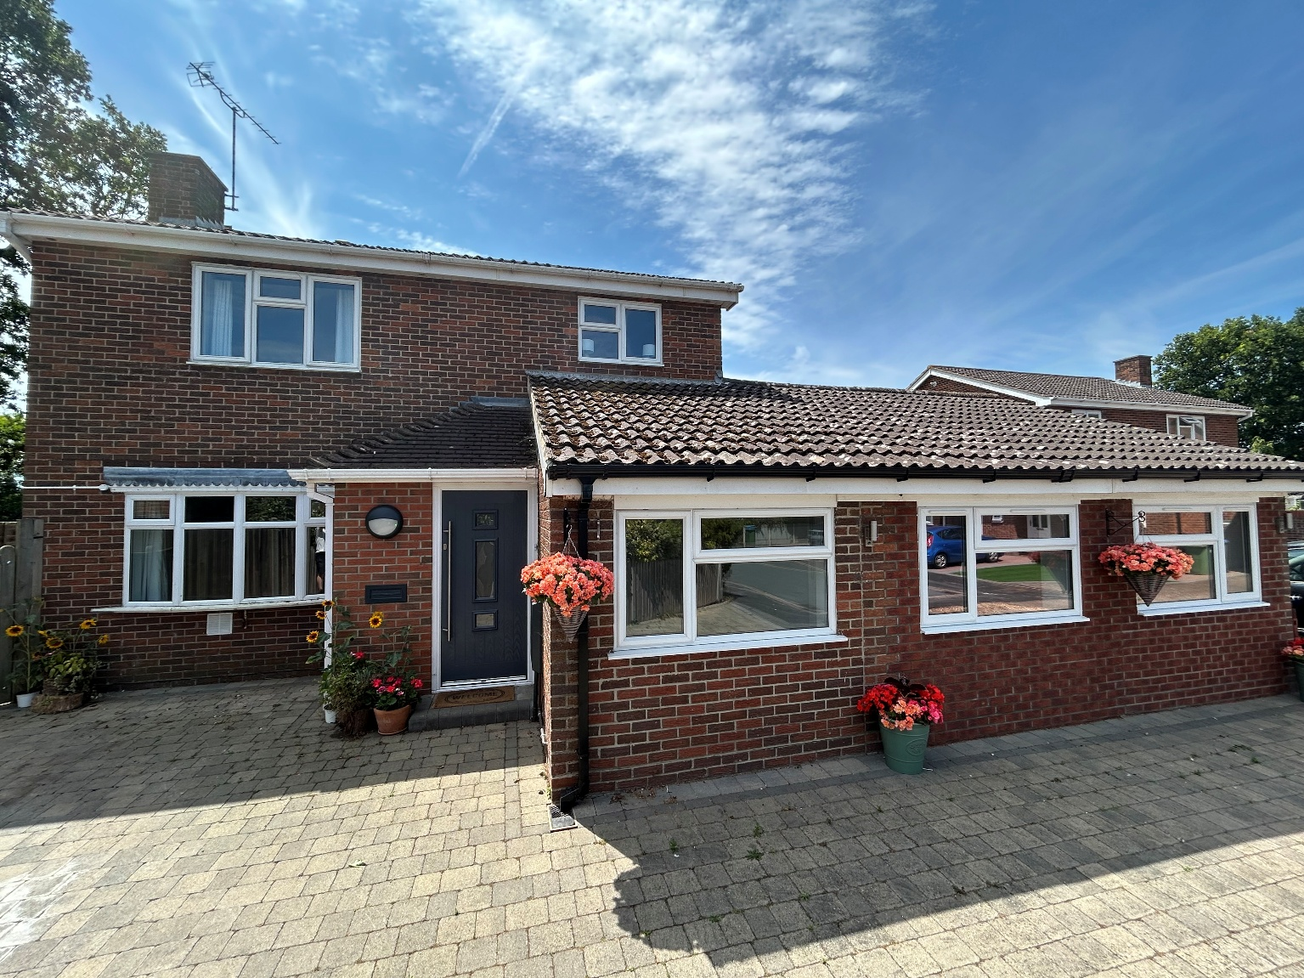

Contents
- Welcome to Cornerstone House
- About Cornerstone House
- Our staff
- Life at Cornerstone House
- Education
- Planning your care
- Family & Friends
- Your personal information
- Help & Support
- Complaints
- Advocacy
- Contact details



Welcome to Cornerstone House
At Cornerstone House we welcome up to four young people from all sexes and genders to come and live with us, we will have young people from age 8-18.
We understand that there are often lots of different reasons why young people come to live with us. We recognise that you may be feeling nervous or worried about moving to a new home, and it helps to have someone to talk to about your worries.
We want you to have a great time with us and for you to be happy, if there’s something you need, please talk to anyone in the team and we will do our best to help you.
You may want to read through this guide with an adult that can support you to think about any questions you might want to ask us, we are more than happy to answer any questions you have.
At the back of this guide you will find our telephone number should you wish to contact us. You will also find some other useful phone numbers, in case you would like to speak to someone outside of Cornerstone House.


About Cornerstone House
Everybody who lives and works at Cornerstone House are different ages and come from a variety of backgrounds and cultures.
Cornerstone House has a large open plan kitchen, dining area, and lounge. The ground floor also has two young people’s bedrooms, a shower room, and a games room. Upstairs has a family sized bathroom, two more young people’s bedrooms, and an ensuite staff office/sleep-in room. There is a really lovely garden and outside areas to enjoy, which can be used for activities, relaxation, and BBQ’s.
We invite you to be part of our community at Cornerstone House. We all work towards helping everyone feel like they belong, are accepted and have trusting relationships. We will help you to explore and manage your emotions, explore your identity what makes you passionate in life.
All young people at Cornerstone House will be expected to be attending school or college and older young people may have jobs. It is very important to us that young people are using their time positively in a way that will benefit your future.
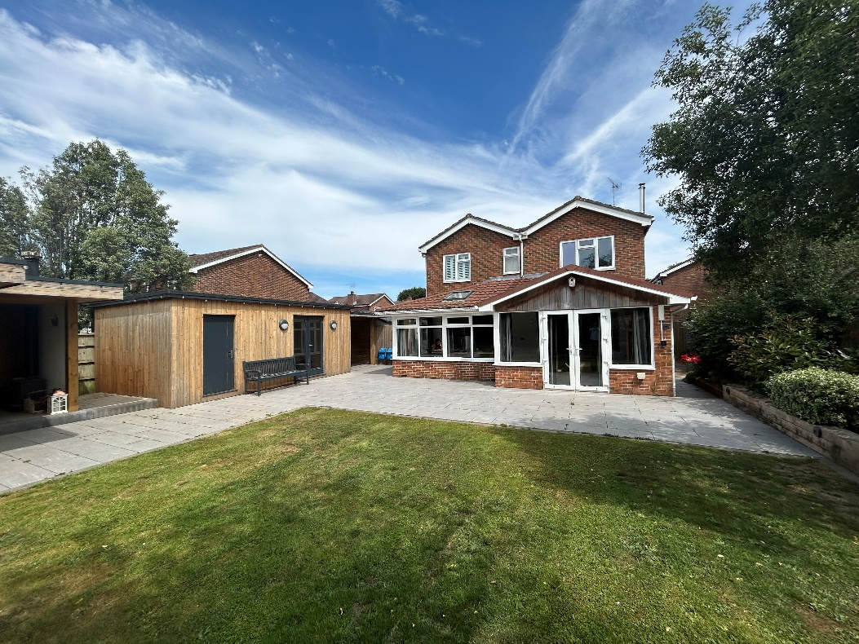
Cornerstone House is located in a village called Stubbington just outside of a town called Fareham, Hampshire. There are lots of nearby parks and outdoor space and we are centrally located between the city’s of Southampton and Portsmouth, we are just a few minutes away from the beach and a short drive to the forest and the Southdowns.

Our staff
A member of the staff team will be available 24 hours a day, 7 days a week.

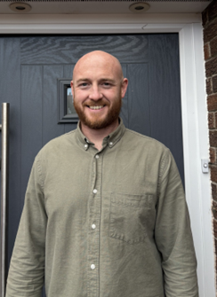













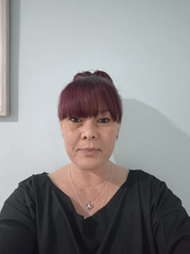
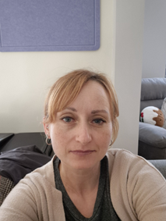

Life at Cornerstone House
Your Bedroom
Your bedroom is your safe space, the one room in the home that is just for you. You will be given a key for this if you would like and we can provide you with a lockable box for your bedroom to store your personal items.
Before to you come to live here, we like to get bedrooms decorated in a way that you like and you will be able to go shopping for things to make your bedroom feel safe and comfortable as a part of your transition to the home.
Staff will not access your bedroom without your permission unless there is a need to keep you safe or a health and safety issue. We may knock for you to wake you up or poke our heads around the door if you are not waking up for school.
It is important to us that your bedroom is always kept clean and we may need to support you to do this.
All young people must knock and wait for an answer before going into someone else’s room. This is being respectful to one another.
Personal Items
We encourage young people to share but we don’t encourage young people to swap things, this is to protect your things and your relationships with your peers. If there are any important things you need kept safe, we can lock them away somewhere secure and you can access them when you want to, we will make a note of these when you move in.
Activities, Adventures, Hobbies & Clubs
We will support & encourage all young people to do a wide range of activities and we will be able to support your current hobbies or clubs you attend either locally or further away. We love saying yes to fun ideas and want you to bring your ideas to us.
We love it when you try new things, don’t worry if you feel worried or scared, we will be with you as much or as little as you need.
If you wish we will arrange and encourage for you to go on group holidays and mini breaks away together to a variety of different places, we would love to be able to plan some holidays abroad if the you would like to.
In the home we will organise regular movie nights, pamper evenings, board games, gaming competitions and whatever our young people our interested in and enjoy doing.
Food
Eating a healthy and balanced diet is important for your growth and development. We recognise that everybody has different food preferences so we are happy to be flexible. Food menu’s are discussed and agreed in regular community meeting and you can request for items on the shopping list. This is your home and so we are happy for you to help yourself to food whilst respecting everybody else in the home. Some young people and often cook for themselves as they are working towards independent living and is something we would like to encourage.
Pocket Money & Allowances
Pocket money is given on the weekend after your bedroom has been cleaned, and you have completed some tasks. This money is yours to spend how you please unless otherwise agreed and we will encourage you to save a small portion of this money. You will have opportunities to earn extra allowances if there is something you are saving for or want to have access to more money and you agree this with your keyworker.
8 & 9 Year Olds - £5
10 & 11 Year Olds - £7.50
12 & 14 Year Olds - £10
15 & 16 Year Olds - £15
17+ - Weekly Allowances
Clothing & Toiletries Allowances
Clothing allowance is £80 a month, this does not include things like school uniform and we can often give extra money for sporting/activity clothing. Toiletries allowance is £20 a month. To begin with you would go out with a keyworker to spend this allowance with a hope towards you being able to go shopping alone or with friends.
Extra Allowances
There are lots of things that we do not have rigid allowances for like phone credit, haircuts, gifts for friends & family and we are happy for you to work with your keyworkers to agree how we will arrange to pay for these. It may be that we agree some target for you to work towards in order to earn extra treats.
WIFI
There is WIFI access within the home that you can put onto your devices. WIFI access will only be given to young people who display that they are able to keep themselves and others safe online. Specific rules around WIFI are not rigid and will be different for everybody depending on a number of factors including how well you are sticking to your other routines.
Travel & Transport
We have cars we can use to take you where you need to go depending on there being a car available. We will always support and encourage you to walk or cycle to locations nearby and for young people working towards independence, using public transport will be part of your normal routines. We can support you to get a bicycle and for older adolescents we can help you learn to drive a scooter or car.
Going Out
It is important to make arrangements with staff when you are going out and to let us know where you are going and when you will be home. It is important for us to know you are safe and well and we can trust you to keep in touch with us if your plans change. If you ever find yourself in any trouble or in unsafe or uncomfortable situations when you are out we want you to be able to call us for support. Your safety and wellbeing is so much more important to us than any mistakes or bad decisions you have made.
Staying Out Overnight
You will need permission from your parents or social worker before you can stay out with friends or at relatives’ houses, this cannot be arranged at the last minute and will need a little bit of planning.

Planning Your Care
Community Meetings
We have regular community meetings where you will be informed about any changes or decisions in the home. This is one of your chances to have your say in how we all live and work together. This is also a time where we plan the food menu, organise activities and discuss feelings and dynamics in the home between young people and staff.
Other Meetings
There will be lots of different types of meetings that may happen in the home or at schools that are important for you to either attend, or to give your views for. It is important that you engage with these so you can make decisions about your future. Staff also have regular meetings in the home where we can discuss as a team any changes you would like to make in the home.
Important Documents
There will be some important documents that your keyworker may want to complete with you or involve you in. We understand that these are not always nice to talk about but it is important to give your opinion on these plans to your keyworker. After we have done these we can go out for a treat.
Rewards & Consequences
We always want to reward you when you are doing well, have achieved great things or put in great effort and on the other hand there may be consequences if you don’t stay within the homes routines and boundaries or behave in an unsafe way. When you arrive at the home your keyworker will discuss all of the homes boundaries and any consequences will always be discussed with you first.
Reflection & Restorative Justice
If you can take ownership of any mistakes, you have made that is a very good way of helping make things right again and to learn from our mistakes. This could be in many forms like a conversation with somebody, an apology or might mean helping tidy or fix something.

Family & Friends


It is important for you to connect with your friends and family to maintain and improve those relationships. When you come to live with us there may already be a plan in place that lets you know how you will stay in touch with your family. If you would like to change the way that you see your family, please talk to a staff member at the home or your social worker directly. We will try to make sure that we support your friends and family to have some great times together and we are open and willing to book activities or arrange days out.
Your friends are welcome to visit the home and we can provide activities for you to do offsite with your friends also. We want you to be open with us about your friendships and encourage you to chat with us if you are ever struggling with any of your relationships. Staff will help support you with how to spot signs of both positive and negative relationships within peer groups.
Education
Everyone under the age of 16 is expected to go to school every day and for young people over 16 the must be in some kind of further education or work apprenticeship.
It may be that school has not always been a pleasant experience for you, and you have missed out on some opportunities. Don't worry - between us all, we will ensure you're in the right place for you, where you feel safe, comfortable and able to reach your potential.
We want you to have fun, make new friends and try new things whilst you are learning. We will help support your education and will have regular contact with your school or college. We will ensure that you have everything you need to learn.
There may be a need for young people to have to work from home during their education. In this case we will ensure that all young people have a quiet place to work & can provide any needed IT equipment & resources.
If you need anything to help you at school please ask!
Your personal information

We take confidentiality very seriously and everybody has private or sensitive information that they would not want other people to know about.
The staff team will have access to information about your experiences before coming to live with us. These include documents about your past that will help us to best support you moving forward. The information we have access to will also allow us to get to know you better. Every day we will write reports about your wellbeing and this information also helps us to make sure that you are receiving the best care possible.
Some of your documents will be stored on a computer system called ClearCare and some of these will be on paper files that are locked away in a cabinet in the office. If you wish to access any of these documents, we can support you to do so.
The people who can see and access your personal information are:
- The managers in the home
- The staff in the home
- Ofsted Inspectors
- Independent Visitors
- Your social worker
- You
If we are concerned that you or someone else may be at risk of being harmed, then we have a responsibility to tell other adults who can help to make the situation safer and this may involve sharing some of your personal information.
Help & Support
While you are living with us we would love to know about the things that you like and don’t like about the home and will check in with you all the time. It is our hope that you can share these feelings with us so that we can make your home a better place to live, we always want to be improving, and would love you to be a part of that journey.
Everybody that comes to Cornerstone House is allocated two keyworkers; these are key members of staff who takes a lot of responsibility for you and your care while you are living here. We understand that you might develop closer relationships with certain staff you feel more comfortable to share with and this is fine.
If you are unhappy, worried or have a problem there will always be lots of adults around that you can speak with. Whether it is a staff member in the home, the manager or maybe even your social worker they should be able to help you.
The home will always be visited monthly by an independent person who is not connected to the home in any way and whose job it is to check up on the quality of care in the home and report directly to Ofsted. We would always advise the you to say hello and get to know them a bit when they visit.
Complaints
If you have asked for help or support and you are not happy with the response you have received or a solution that has been put in place you are able to make a complaint.
You can make a complaint to any of the adults mentioned above and you can either speak with them, write it down or ask them to write it down for you.
Once you have made a complaint we will always speak with you about this within a few days and hope to get your issues resolved as quickly as possible. If we are unable to resolve your issue or you are still not happy with the way we have responded, we will involve your social worker to join us to try and resolve this for you as a group.
There are lots of other people and services you can contact if you are unhappy about anything in the home and you don’t feel comfortable speaking with us or your social worker.

Childline
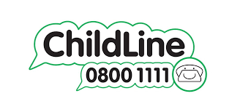 | Childline is a free, private and confidential service where you can talk about anything. You can do this online or on the phone, at any time, day or night.  Contact Childline on 0800 1111  Email from the website on:  https://www.childline.org.uk/get-support/contacting-childline/  Or you can 1-1 online chat on:  https://www.childline.org.uk/get-support/1-2-1-counsellor-chat/
The Children’s Commissioner

Dame Rachel de Souza is the Children’s Commissioner for England.
Her job is to speak up for young people so that people who make decisions that affect them take their views into account. She speaks to young people and listens to what they have to say.
There is a free and confidential support service for young people who are living in a children’s home, and for young people who are leaving care. You can phone 0800 528 0731 or you can email on help.team@childrenscommissioner.gov.uk

Ofsted

If you are not happy with the way your complaint is managed at Cornerstone House, you can contact Ofsted.
Ofsted have a responsibility to visit the house regularly to check that you are being looked after and that you are safe and well, they will want to speak with you when they visit. The staff at Cornerstone House or your social worker will help you to contact Ofsted if you want to.
Telephone: 0300 123 1231
Email: enquiries@ofsted.gov.uk
Advocacy
An Advocate is someone who can help you understand your rights and can help you to say what you think when decisions are made about your care. They will help you to be heard if you want some help, or to be listened to.
Any of the adults around can help you to seek support from an advocate or you are able to contact them yourself.
Coram Voice

A leading children’s right organisation who champion the rights of children. Their aim is to get young peoples voices heard in decisions that matter to them and to improve the lives of children that are living in care.
Telephone: 0808 800 5792
Email: help@coramvoice.org.uk
Website: https://coramvoice.org.uk/

Voice Ability

An independent charity and one of the UK’s largest providers of advocacy service to young people.
Telephone: 0300 303 1660
Email: helpline@voiceability.org
Website: https://www.voiceability.org/

Contact Details
Home Telephone Number: 01329 745716
Manager Telephone Number: 07767 920593 (Ben)
Website: Fourcorners.org.uk
Updated on 14/11/2025

